www.judonb.orG

17 th

coupe “Max steel” cup

clair, nb

Date: Saturday, February 16th, 2019

Location: Centre d’Apprentissage du Haut Madawaska, 323 Boul. Long, Clair, NB
(Right at Home Hardware, first street on right Approx ¾ km)

Eligibility: U6, U8, U10, U12, U14 and U16. The format of the tournament is to promote judo for kids in a safe and fun environment and to do so, the competitors will be match with other competitors with the same belt division, same year of birth and weight class as much as possible. All competitors must be member of their provincial association.

REGISTRATIONS Coach honor system will be used. Coaches, please send info to Daniel Ouellet by Friday, February 15th at 5 pm. Checkins on the morning of the tournament between 7h00 and 9h00 AM.
Canteen on the site with breakfast served this year. The competition will start at 11h00.
Registration fee: $ 30. $10 extra to fight in two divisions.

Tournament: Fights that involve a white belt and U6 and U8 – ne waza (ground)
Colored belts, U10, U12, U14 and U16 – tachi waza (standing)

Tachi waza : 3 min of timed fight with regular points system
- No grabbing around the neck or under the belt
- No drop on the knees and no sacrifice technique.
Ne waza (Modified rules): 2 min of actual fight
- Need 3 ippon (30 points) to win or most points after time is over.
- No grabbing the neck.
- Turn over are 5 point.

Host: Bushido Judo Club, Clair, NB

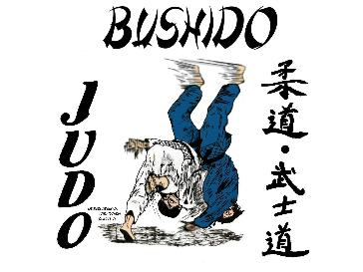

Information: Daniel Ouellet, Tel : 506-992-9820 senseidanju@yahoo.fr
Cell : 506-733-7481

Accomodations: Morel. Airbnb in Edmundston
https://www.airbnb.ca/users/160722820/listings?user_id=160722820&s=1
Denis Levesque
denis.craneoperator@gmail.com
506-735-77212

Motel Restaurant Bar La Faim de Match. 80.50$ including taxes. At 9 km.

https://mapcarta.com/ChIJAZTNvIy7oEwRcczeTf05_N4

Many thanks to our sponsor for the past 17 years

Max Steel Inc. Mario Nadeau 506-992-3311

Mario.nadeau@maxsteeldesign.ca

Welding, steel structures, custom made orders

www.maxsteeldesign.ca

2019 Max Steel Cup TOURNAMENT: REGISTRATION
CLUB: |  |  | TECHNICAL DIRECTOR:
Last Name | First (Given) Name | DOB  DD/MM/YYY | Sex | Belt | Weight (KG)

