2020 Atlantic Open
April 18th and 19th
*Technical Package Updated February 17, 2020
LOCATION: Credit Union Place
511 Notre Dame St,
Summerside, PE
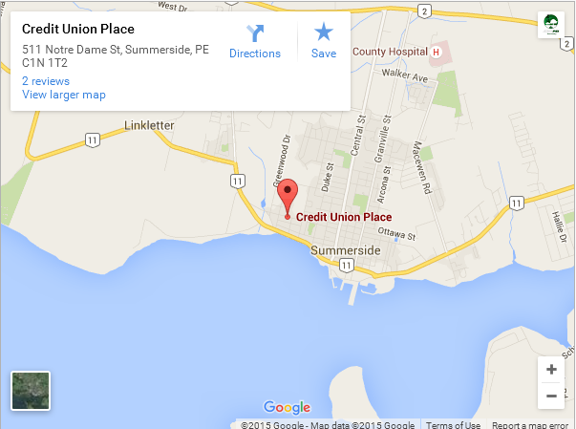

https://goo.gl/maps/NotbD63opy72
Information
Tournament Organizing Chairperson: Brian Nash 902-303-2874 Email info@atlanticopen.org
Registrations: Email : registration@atlanticopen.org
Referee Co-Ordinator: Sandra MacDonald Email: macdonald4040@gmail.com

SCHEDULE
 | Friday April 17th  Registration Check In  Credit Union Place: 511 Notre Dame St, Summerside  All Divisions: 4:00pm – 8:30pm  Weigh In  Credit Union Place: 511 Notre Dame St, Summerside  U14, U16, U18, U21 and Senior  Non-Official Weigh In: 4:00pm – 8:00pm  Official Weigh In: 4:30pm – 9:00pm  Saturday April 18th  Registration Check In  Credit Union Place: 511 Notre Dame St, Summerside  All Divisions: 8:00am – 4:00pm  *U14 and U16 must Check in By 9am  *U18 and U21 need to Check in by 10:00am  Competition  Credit Union Place: 511 Notre Dame St, Summerside  Opening Ceremonies and Bow In - 9:00am  U14 - 9:30am  U16 - *11:00am  U18 - *1:00pm  U21 - *2:00pm  Seniors - *3:00pm | Sunday April 19th  Registration Check In  Credit Union Place: 511 Notre Dame St, Summerside  Weigh In  Veterans  Non-Official Weigh In: 9:00am – 10:30am  Official Weigh In: 9:30am – 11:00am  All Divisions: 8:00am – 12:00pm  *U10 and U12 must Check in By 9am  *Veterans need to Check in by 11:00am  Competition  Credit Union Place: 511 Notre Dame St, Summerside  U10 - 9:30am  U12 - *10:30am  Veterans - *12:30pm  * IMPORTANT: All participants must come to the official weigh-in with their Judo Canada membership card, their accreditation, a picture ID is required for all competitors U16+.  For U16 and above both a blue and white gi are required.

Divisions
U10 | U12 |  | U14
2011 - 2012 | 2009 - 2010 |  | 2007 - 2008
Combined | Combined |  | Male |  | Female
*6 Closest Weights | *6 Closest Weights |  | -31kg, -34kg, -38kg, -42kg, -46kg, -50kg, -55kg, -60kg, -66kg, and +66kg |  | -29kg, -32kg, -36kg, -40kg, -44kg, -48kg, -52kg, -57kg, -63kg, and +63kg
U16 |  |  |  | U18
2005- 2006 |  |  |  | 2003- 2005
Male |  | Female |  | Male |  | Female
-38kg, -42kg, -66kg -50kg, -55kg, -60kg, -66kg, -73kg,  and +73kg |  | -36kg, -40kg, -44kg, -48kg, -52kg, -57kg, -63kg, -70kg,  and +70kg |  | -46kg, -50kg, -55kg, -60kg, -66kg, -73kg, -81kg, -90kg,  and +90kg |  | -40kg, -44kg, -48kg, -52kg, -57kg, -63kg, -70kg, and +70kg
U21 |  |  |  | Senior
2000 - 2005 |  |  |  | 2005 or Earlier
Male |  | Female |  | Male |  | Female
-55kg, -60kg, -66kg, -73kg, -81kg, -90kg, -90kg and +100kg |  | -44kg, -48kg, -52kg, -57kg, -63kg, -70kg, -78kg, and +78kg |  | -55kg, -60kg, -66kg, -73kg, -81kg, -90kg, -90kg and +100kg |  | -44kg, -48kg, -52kg, -57kg, -63kg, -70kg, -78kg, and +78kg
Veterans
F1/F2 & M1/M2 1989-1980 F3/F4 & M3/M4 1979-1970 F5/F6 & M5/M6 1969-1960 F7/F8 & M7/M8 1959-1950
F9/F10/F11 & M9/M10/M11 1950 and earlier
*The Organizers reserve the right to combine any divisions where there are less than 3 competitors

Rules
Draws
The tournament will be conducted under the rules adopted by the IJF as of January 1, 2018
Divisions of 5 or less will be a pool system – Divisions of 6 or 7 will be conducted as a double pool
All divisions of 8 or more will be done as a modified double elimination
U10 and U12 divisions will be based upon coaches honour and individuals could be subject to challenge from another coach or tournament officials if they feel there is a discrepancy.
U10 will be competing under Modified Fair Play Rules – of 3 Ippons
The IJF Team Competition guideline will be followed.
Draws and medal awards will follow the same rules for individuals based on the number of Teams Registered.
Medals & Awards
Double Bronze will be awarded in divisions of 6 or more
In order to receive a medal in U14 and above a competitor must record at least one win
All Competitors in U10 and U12 will receive a medal regardless of wins those who did not record a win may receive a modified Bronze Medal

Registration
Costs
 | Before  April 1st | Between  April 1st – 16th | After  April 16th
U10 & U12 | $30 | $35 | $40
U14 | $35 | $40 | $45
U16 & U18 | $45 | $50 | $55
U21 & Senior | $50 | $55 | $60
Veteran | $45 | $50 | $55
Team | $125 | $150 | $175
2nd Division | $20 | $25 | $30
Open | *Registration for open will be taken at venue during tournament |  |  | $20

* No refunds will be granted after April 1st and all refunds prior to April 1st will be subject to a $5 processing fee for individual registrations
Process
All registrations must be done through the forms found on the official website www.atlanticopen.org after February 10th
All U10 and U12 registrations must be submitted on a club registration form
Referees:
Please contact Sandra MacDonald Email: macdonald4040@gmail.com
Referees must have proper attire for tournament.
Note: There will be a Referee session (Rules) on Friday April 17th starting at 7:00pm
Official Hotel
Quality Inn
618 Water Street, Summerside
Phone: (902) 436-2295
Rates:
TBA

